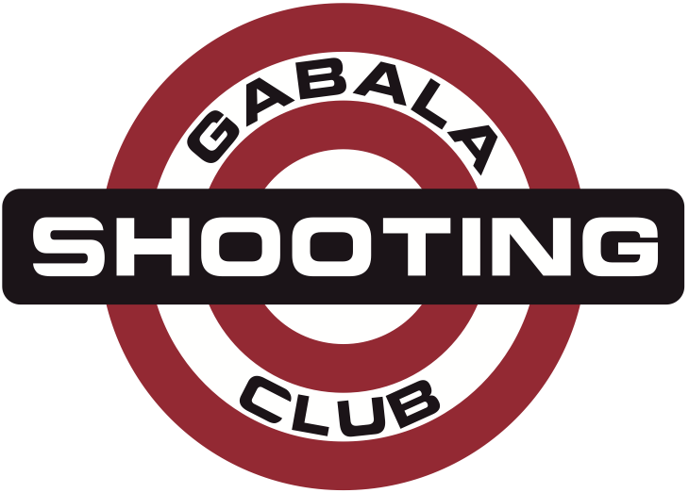
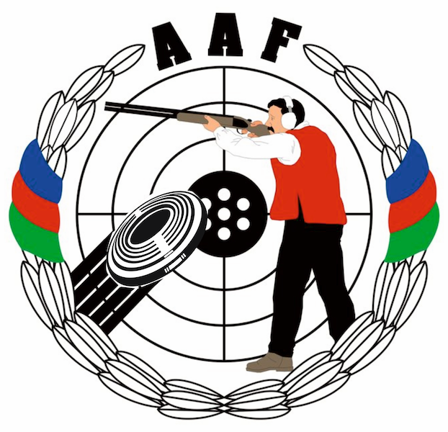
HEYDAR ALIYEV
INTERNATIONAL GRAND PRIX
Gabala, Azerbaijan
14 – 21 August 2014

Please email to Organizing Committee: info@gabala.eu
FINAL  ROOMING LIST FORM |  | Please return by |  | to Organizing Committee
name of federation |  | 15 JULY 2014 |  | Lermontov str. 68  Baku, AZ1066, Azerbaijan  Phone: +994-50-5141515  Phone: +994-55-7537775  E-mail: info@gabala.eu
hotel
single
no | name |  | check in date |  | check out date | number of nights
double / twin
no | name |  | check in date |  | check out date | number of nights
Triple or Cottege
no | name |  | check in date |  | check out date | number of nights

